DEUTZ Xchange
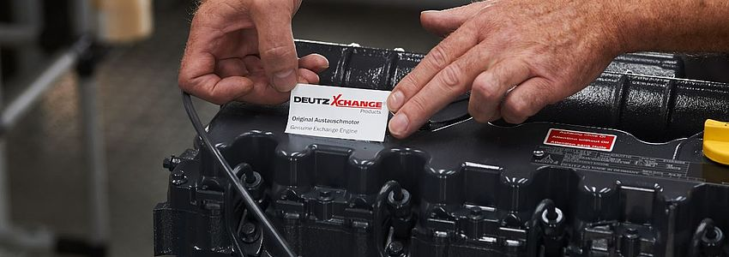
The fast and economical alternative.
A new life for old machines – professionally remanufactured engines and parts are a fast, economical and environmentally friendly alternative to buying new.
DEUTZ remanufactured engines and parts offer optimum functionality and safety: All our Xchange products are manufactured according to strict quality standards and are thoroughly tested regarding part quality, fit and function. The result is reconditioned products that are equivalent to their new counterparts in all aspects, even if serial production was discontinued years ago.

Xchange Parts
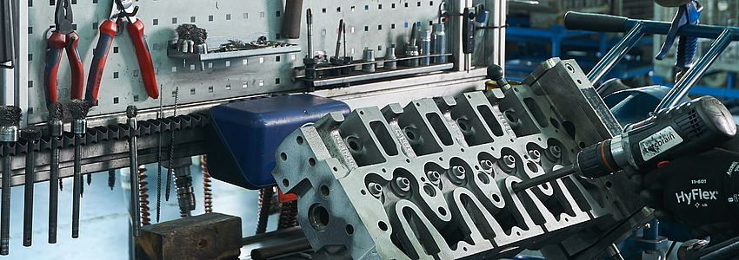
Our experiences - your advantages
Compatibility and the legendary DEUTZ quality are the key features of all Xchange components. This way we ensure that the full performance and reliability is restored after reconditioning.

Profit from our remanufactured DEUTZ spare parts:
- Warranty equivalent to new DEUTZ parts
- Up to 40% lower price compared to new parts with guaranteed quality and functionality
- All wear parts replaced with DEUTZ original new parts
- Immediately available for installation via worldwide DEUTZ service network
- Also available for complex DEUTZ engines of EU Stage III A / US EPA Tier 3
- Environmentally friendly and resource saving

Before vs. After
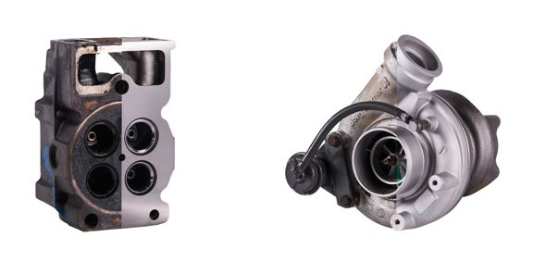

Our Xchange product range:
- Turbocharger
- Air compressor
- Cylinder head
- Injector valve
- Starter
- Generator
- Speed govenor
- Air pump
- High-pressure pump
- Fuel control unit
- EGR-module

Short- & Longblock

The economical alternative.
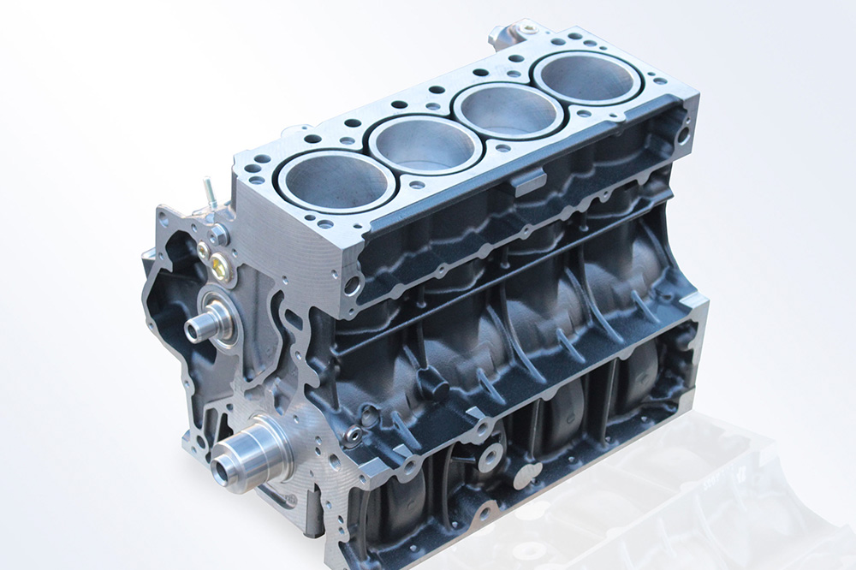
For cost-efficient engine overhauls, DEUTZ offers short and long blocks as a rapid and economically-priced alternative to a complete Xchange engine.
The advantages at a glance:
- Highest quality
- Same warranty as new DEUTZ Parts
- Low prices
- High availability
- Quick and simple processing
- Professional consulting

Shortblock
Short blocks contain the refurbished core engine including the crankcase and core components such as camshaft, crankshaft, piston rods and pistons as well as the engine gasket set. DEUTZ medium-cooled 4 -8 Liter short blocks are equipped with the oil pump as an additional component.

Longblock
Long blocks additionally contain the valve control system as well as the complete cylinder head.

Xchange Engine

Fast availability.

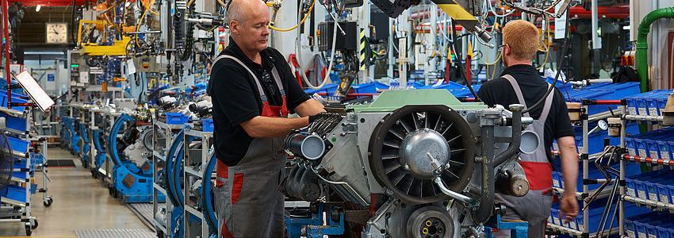
The fast and economical alternative.
From construction machines, pumps, vehicles, underground mining equipment, power units in ships to the agricultural sector: DEUTZ Xchange engines are available for each machine age and all engine types of the past 45 years.
- More than 150 years of experience in engine construction
- Worldwide authorized DEUTZ service network
- Disassembly, cleaning, parts testing and replacement, assembly and inspection are all performed according to DEUTZ specifications
- All engines are brought up to the latest technical stage of development
- Warranty equivalent to new DEUTZ products
- No hidden costs, easy-to-track investments over the entire service life
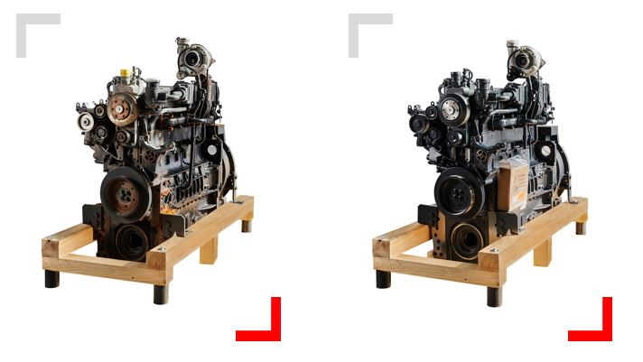

DEUTZ Xchange Reman Process
With our DEUTZ Xchange reconditioning process you will receive a DEUTZ Xchange engine with the highest quality standards. Here you can gain an insight into the individual process steps that guarantee a product that is manufactured with and according to the latest technical know-how on state-of-the-art machines.

